Effective Practices - by Ken Nagel
I put together this simple practice plan and a few sample drills to give new coaches an idea on how to structure a good practice, which utilizes your practice time as effectively as possible. You’ll need to be sure to tailor the plan, times, and drills based upon the ages and skill levels of your team. There are many variations to practice plans and hundreds of sites with drills, so this was a sample based upon my experiences. Be sure to leverage as many resources as possible, including other coaches in the league and the information on the web. Finally I encourage the coaches to provide feedback and other ideas and your favorite drills. You can contact me at 4nagels@gmail.com
Thanks and have a great Practice!
The Practice Plan – Set Goals
Your first need to have a goal for the practice, whether this is to improve a specific skill set for the team, work on general fitness, or work on special plays; at the end of the practice you should be able to say to yourself and the team you met the goals you wanted to achieve.
The coach’s goal should always be to include each player and minimize or remove the amount of time players are not engaged. Having twelve players in a line to receive ground balls means eleven players are standing around doing anything else except learning. Break up the practice into different stations with dedicated coaches working on specific tasks. For example with a team of 12 girls you should have at least 3 stations with 4 players each working on a specific task for X amount of time, and then rotate them around to each station. Each station must have at least one coach at it working on the tasks, so get the parents involved and recruit them as a coach . This allows the manager to delegate to other coaches, focus on specific areas, and provides for a much more effective use of the players time.
Create a Practice Plan.
Before every practice create a schedule or practice plan, similar to a teacher’s lesson plan. You usually only have 2 hours to practice, which if properly planned out will seem like minutes, however without it will seem like an eternity and the players will be restless and bored . One of the hardest parts for you as a coach is to make sure you have done your drill homework ahead of time and can clearly explain each one to your players without wasting time. If you cannot explain how the drill works, you could also run the risk of players getting hurt. Write them down in your practice notes if you have to, I usually scribbled small diagrams on my plan to refresh my memory at practice. You can even draw this out for the players or coaches (I have brought small white boards to practice before which helps), whatever works best for you.
Here’s a sample; remember the age and skill levels of your team will change the amount of times and types of drills, so use this as a guide:

Practice Plan -- Tuesday xx/xx/xx
Skill: Beginner
Goal – Improve Offense & Defense

5:30 – 5:55 Base running – Conditioning
5:30 – 5:35 Review today’s concepts and goals
5:35 – 5:45 “Team Tag”
5:45 – 5:55 “3,2,1”
6:00 – 6:25 Throwing – Fielding
6:00 – 6:05 review drills objective and concept
6:05 – 6:15 Warm up throwing & “partner throws for time”
6:15 – 6:25 “Throw and Go”
6:30 – 6:55 Hitting, bunting, slapping
6:30 – 6:35 review drills concepts and objectives
6:35 – 6:55 Hitting Station(s)
Station # 1
- Soccerball hit off “T”
(use a soccerball slightly deflated, and place on the T, improves strength and follow through)
- Soccerball hit off bounce
(use a soccerball slightly deflated but still “bounceable” bounce and hit into the net)
Station # 2
- Pizza Throw
(you can use a Frisbee; have the batter hold the Frisbee in both hands in a batters stance – palm up – palms down, and “bat” done correctly the Frisbee should fly, teaches proper form and palm up/palm down stance )
- Popcorn hit
(use popcorn kernels, soft toss to the hitter – be sure to do this safely usually hitting into a hill)
6:55 – 7:00 wrap up
use this time to wrap up, review the practice and make any announcements to the team about upcoming practices or games.
Drills:
Team Tag
Skill Level: Beginner and Advance
Instead of having the team run and do calisthenics, Team Tag is a great way to do conditioning, it also helps with quick agile running, and quick cut moves they would use in the infield and it’s easy and fun.
You can have the entire team do this drill and only take a few minutes. It’s essentially a game of tag, as you can see from the picture below; we setup the cones into a small diamond in the infield, with an imaginary line (you could draw lines as well). You select two players as “It” and have them wear their helmets. The others start outside the cones, and enter on the word “GO”. The “helmetheads” then try to tag as many players as they can. Do 60 second intervals and if a player is tagged or they go outside the “basepath” (or the imaginary line) they are out, and the “helmetheads” get a point. Rotate this around to different “helmetheads”. Do this for 5 to 10 minutes at most, and the team will get a great and fun work out. I have used this for every age group in the division and they all love it.
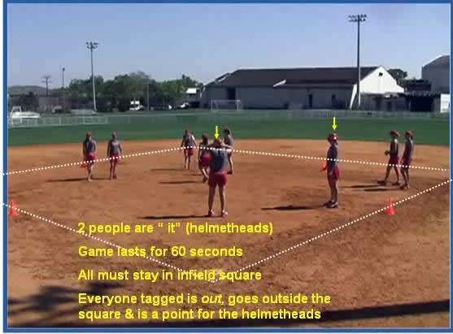

Drill: “3-2-1”
Sill Level: Beginner and Advance
This is a fun base running drill. Have your team line up and home base in groups of 3. 3 players start the run at the same time, the first runner sprints to 1B. There is a variation on this called 4-3-2-1, but will cover this as another drill.
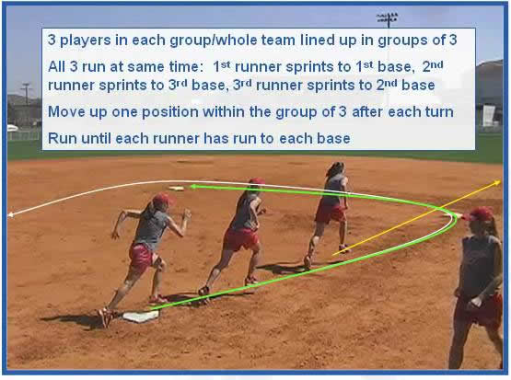
Drill: “partner throws for time”
Sill Level: Beginner
This is an easy and fun throwing drill using a partner and a level of competition for each pair. It also improves their skill levels for throwing under pressure.
Set the team up into two lines as shown below, spread apart enough to throw back and forth comfortably. Have a stop watch or use your watch and when you say “GO”, they begin to throw and each time they catch the ball they count, once they stop the pair with the highest number wins a point or a prize. Do this several times or use a total points system say the pair who reaches 50 wins. Also bring a prize, red licorice works or something similar.
A variation on this is partner throw for #’s – same setup, no time limit; on “GO” – they begin to throw back and forth and like an egg toss when you say “back” one of the lines moves back one giant step back. If a pair drops the ball or misses a catch they’re out – the pair who lasts the longest wins a prize.
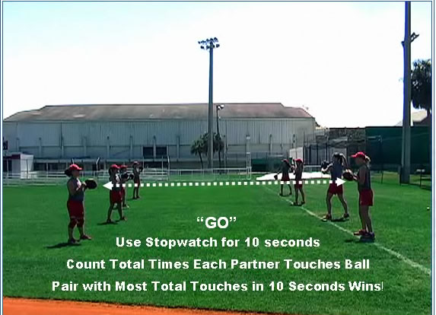

Drill: “balled up Throws”
Sill Level: Beginner and Advance
This is a great drill to encourage team work, and throwing accurately under pressure.
Split your team up into small groups of 4 or 5 players per group. Everyone has their gloves and each group starts out in a balled up group. Use a fence line or wall (or setup a cone where the fence would be) for the starting line and depending upon the age group home plate as the ending line (or again another cone). One ball is placed at the starting line (the fence) for each team.
When you say “GO” each group sprints into position and the first person in each group sprints to the ball and throws to the 2nd player, then 3rd, then home – the first team to finish wins a point.
It’s up to each “balled up” group to work as a team and decide where they are going to go in order to complete the relay play, but every player in the line must catch, turn and throw the ball
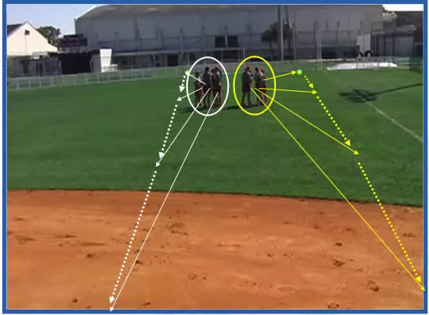
Variations:
- For younger players you could help this by placing cones for each cut-off position, then after they do this a couple of times take the cones away.
- Time it to make it more challenging.
- Even more challenging – when the ball reaches the last person, have them drop it, pick it up and throw it back down the line to starting line
- Decrease the number of players per line or increase the numbers.

